ASSEMBLED PARTITION AS FARM OUT / PURCHASED ITEM

The following screens represent the files to build to create an estimate for an assembled partition that will be purchased, drop shipped by the vendor and invoiced directly to customer. For chipboard board material such as SBS, Bending Chip, SUS and other substrates, the folding carton style file must be created for both components.

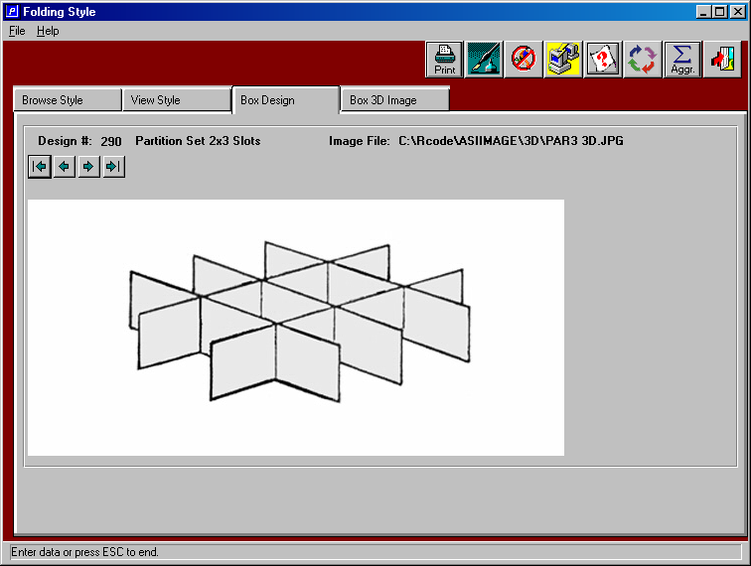

Adding the Estimate as Complete Set to be Quoted

The + icon provides the ability to create an estimate by entering the customer code, part number, style, board grade and length, width and depth (height). By indicating that this item is purchased, the folder called FARM provides a cost matrix for each vendor.
In this example, I enter the entire finished partition.

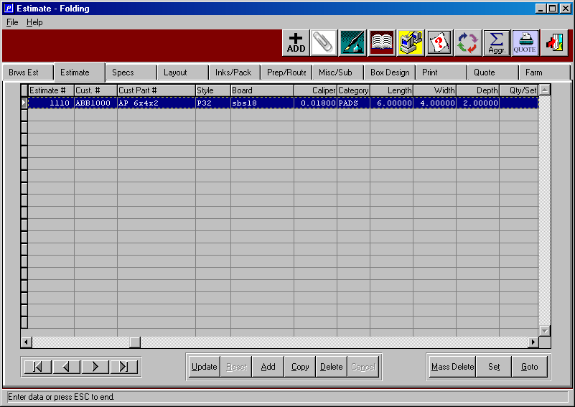

Adding the Vendors Quoted Prices

Your company can request quotes for many vendors and save the costs for numerous quoted quantities. In this example, I have defined a cost per thousand (Per M) for ten different estimate quantity breaks. I could enter just one cost for any quantity or I may enter a separate cost for different estimate quantities that the customer may have requested. The cost estimate calculation will pick the best cost by vendor. In this example, an estimate quantity from 5000 to 10000 will import a cost of $95 / M.

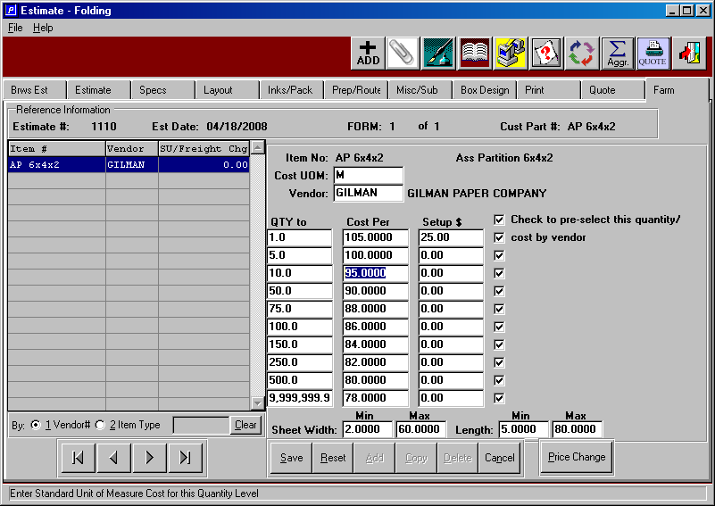
Option of Adding Estimate as Set with Components

If you are going to buy the length partition from one vendor and the width partition for another vendor, you could estimate the assembled partition as a set and receive separate cost quotes for the width and the length. However, the quote to your customer will still be quoted as a finished assembled set. In this example, I enter the set part number for the assembled partition item. However, I also list both the length and the width partition separately on the estimate folder. This method provides the option to receive separate quotes for each component and this also provides the flexibility to ship the entire assembled partition or to ship the length and the width separately.

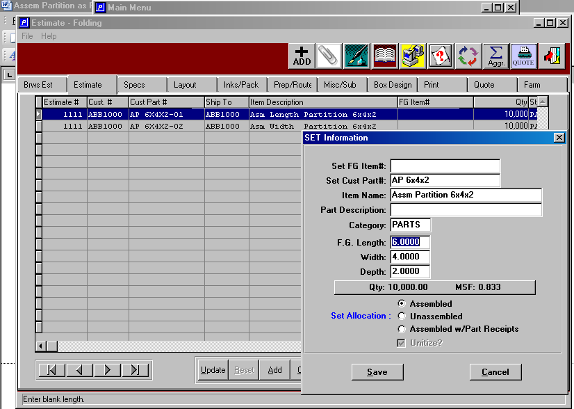
Unlimited Board Material Options are Available

The F1 search key on the board field will list all raw materials defined in the raw materials file. The actual cost per Ton, MSF or per M may be stored for each material to see the cost of the what the partition manufacturer is buying paperboard sheets. Add machine labor and you can guess the cost of manufacturing.

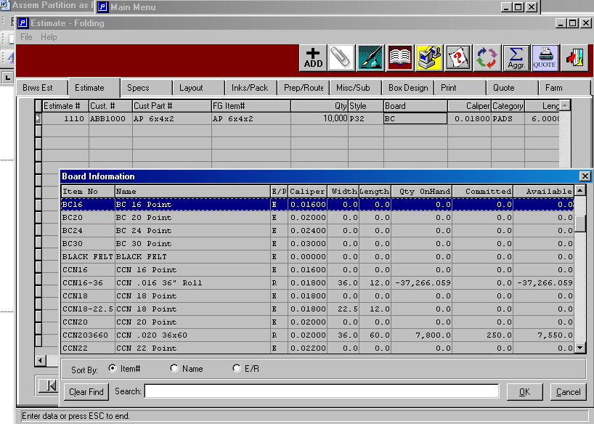

Estimate Calculation

The Print Folder provides the button to calculate the cost to provide a quote. The estimate can use various markup percentages for commissions, warehousing, pallet charges, general selling and administration and other broker defined contribution factors. The system calculates out of pocket direct costs, full cost with markups and sell price with gross and net profit percentages.

